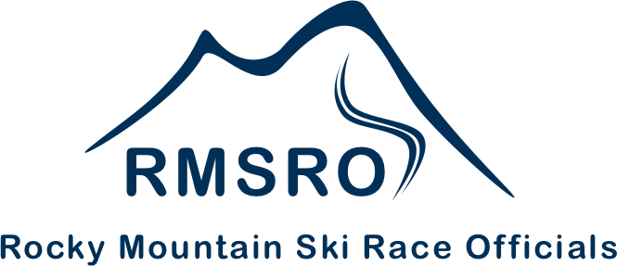

**Annual RMSRO General Membership**

**Meeting Minutes**

**10-28-2023**

1. Call to Order @ 9:00 by Ken Gay, President

2. Attendance: K. Gay, C. Ogilvie, J. Jett, P. Daley, C. Zeiter, D. Zurbay, T. Herbst, PJ Jenick, E. DelliQuadri, D. Verdun, J. Moyer, M. Richardson, S. Bonde, J. Paul, D. McCarthy, P. Miller, C. Jett, T. Ptack, K. Kolar, M. Bond, H. Armstrong, H. Monroe, L. Foulk, R. Perricone, M. Bowman, S. Scherer, B. Feroldi, K. Revello, R. Rupert, J. Westcott, D. Lakatos, R. Liu, B. Lee, C. Greer

3. Approval of Agenda, Motion by PJ Jenick, 2nd P. Daley, approved

4. Approval of Minutes from 11-5-2022, Motion by D. Verdun, 2nd by PJ Jenick, approved

5. President’s Report by Ken Gay

a. Clinic Update – Back to In-Person for all Clinics except CE

b. Status of Virtual Updates / CE Only

c. New Location, CMC Campus, TD Update and Certification Clinics next week.

d. Satellite Clinic Discussion

e. TD Assignments will be distributed later by J. Jett

f. RA Update Workshop will be required every year going forward, just like TD update

1) Objective is for everyone to stay sharp and be aware of changes in requirements.

g. Thank you to the RMSRO Board of Directors, K. Gay-President for 5 years, PJ Jenick-Vice President, G. Wright-Legal Consultant & Past-President, J. Jett-Web Master & Timing for US Ski & Snowboard, T. Ptack-Member Database Manager, T. Herbst-Education Coordinator, P. Miller-Secretary/Treasurer, K. Ghent

6. By-Laws Update was circulated to members. Move to accept changes by PJ Jenick, 2nd P. Miller. Discussion: Change all instances of US Ski & Snowboard and U.S. Ski Association to United States Ski & Snowboard. Motion amended to include said changes. Motion passed.

7. Volunteer Recognition Program Update

a. Objectives: Develop programs to certify & provide recognition

b. Encourage people to move through certification levels

c. Our objective is to help people to move through levels.

8. Motion by P. Miller to donate $250 to RMD for Golf Tournament, 2nd by E. DelliQuadri, motion passed.

6. Financial Report by Treasurer, Pat Miller – See attached.

Motion to accept by P. Daley, 2nd S. Bonde, motion passed

8. 2023-2024 Clinic Schedule discussed

a. Next Year; Annual Meeting before TD Update on Nov 2, 2024; 1 week after the FIS Update

9. Masbruch Award – Kelly Ledbetter recipient; top award for RMD Official

10. Service Awards: Frank Mangold, Eileen Martin, Francois Nanin, Greg Johnson

11. Election of Trustees: Terms Up: a. E. DelliQuadri b. PJ Jenick c. K. Gay

All have agreed to serve another term.

Motion by J. Moyer to accept the slate, 2nd by D. Verdun,

Election of slate, unanimous

12. Old Business: None

13. New Business: None

14. Motion to Adjourn by PJ Jenick, 2nd S. Bonde, unanimous,

15. Meeting adjourned at 9:45 PM