**Checklist for Boards & Draw for Nor-Am Cup Races – Season 2023-24**

|  |  |  |
| --- | --- | --- |
| ***Details*** | ***Rule*** | ***Supplied by*** |
| **QUOTAS** |  |  |
| **International Entries**  • FIS Continental Cup quotas - updated at regular intervals during season  • Conditions for Qualification - Basic Quota of 2; 3 for DH  - National Quota   * Organizing nation has the right to allow nations from other regions up   to their normal FIS quota on consideration of the number of entries and conditions and must be ranked in top 1000 as follows: **GS/SL/P** - any event; **DH** - DH or SG; **SG** - SG, DH or GS; **AC** (with DH) – DH or SG; **AC** (with SG) – DH, SG or GS. Request must be filed 10 days prior to 1st training/event; OC decision will be made seven (7) days prior to 1st training/event.  • Normal FIS quotas | 2.1  2.2  NAC 2.3.3  2.1  2.2 | FIS website  COC rules  ICR |
| **National Entries**  • CAN and USA: up to 60 competitors in each race organized in other nation.  • Organizing nation (CAN or USA) may enter a basic quota of 60, in addition they are entitled to any of the 60 places the other nation does not fill (NAC.2.3).   1. All competitors must appear on the valid FIS list. 2. NAC event maximum quota of 120 for USA and CAN (plus 1 if winner is from either nation) must not be exceeded. 3. Alpine U.S. Nationals will have same quota when an NC DH is scheduled during the Nor-Am Cup Speed Series. | NAC 2.3  NAC 2.3.1  NAC 2.3.1  NAC 2.3.1.1  NAC 2.3.3.1 | Selections and entries made by respective National Office |
| **Winner of Nor-Am Cup in the respective event**  • Winning nation from prior year (USA or CAN) receives additional start (s) which are listed on Continental Cup quota sheet. | 2.4  NAC 2.3.1  NAC 2.3.1.1 |  |
| **Additional Competitors for Downhill Training / Downhill & Alpine Combined**   * DH only: Teams are permitted to start with additional competitors based on calculated quota totals (up to 7 allow 2 additional; 8+ allow 3 additional). * DH & AC: Teams permitted to start with higher calculated quota +50% +COC winner | 2.5  2.5.1  2.5.2 |  |
| **START ORDER** |  |  |
| **Requirements**:  • The final event ranking in the Cup - called the “Basic List” - is used as race result with a validity defined in art. 3.1.3 where last year’s standings for the top 30 (allocating points for positions 1-30 as for a single race) added to the current seasons points to determine new ranking.   * Sum of the Nor-Am Cup Standings points of the past season in the respective event will be divided by four (4) in technical events, three (3) in speed events, and two (2) in Alpine Combined. This establishes the points that will be deleted after each race. * At the Nor-Am Cup Finals, only points achieved in the current season are valid. | 3.1.3  NAC 3.1.4 | **Note: If due to cancellations, only 3 technical events or 2 speed events are scored, only points achieved in the current season will be valid at Nor-Am Cup Finals.** |
| **First Group (1 - 15)**  • Top 15 competitors present according to current Nor-Am Cup Start List in the event.  • For first GS, SL, DH, SG, and AC, the ‘Nor-Am Cup Basic List’ (based on previous season’s standings) is used. Points are updated after each event as follows:   * After each GS, SL, DH, SG, and AC, a portion of the Basic List Points is deleted as outlined in 3.1.4, and points earned in the current event are added. This calculation establishes a current Nor-Am Cup Start List. * After 4 GS, SL, 3 DH, SG, and 2 AC, the Basic List has been fully deleted and only the points earned in the current season in the respective event are used.   • In case of a tie for 7th place (SL/GS), the first group is expanded to include all competitors with the 7th best cup points.  • In case of a tie for 15th place (all events), the first group is expanded to include all competitors with the 15th best cup points.  • If two or more competitors have the same Nor-Am Cup points, then the order on the board is determined by their FIS points in that event.   * If two or more competitors have the same Nor-Am Cup points and FIS points in that event, the order on the board is determined by a draw.   • If there are not 15 competitors present with Nor-Am Cup points first group comprises only competitors with respective Cup points. The only exception is, for the first race of the season, the next ranked competitors from the previous season’s Nor-Am Cup standings are added to fill the first group. | 3.1  3.1.3  3.1.4  NAC 3.1.4  3.1  NAC 3.1  3.1  3.1.3 | **Note: Following receipt of an event’s XML file, Nor-Am Cup Start Lists (used for seeding) and Nor-Am Cup Standings (current placings) will be immediately updated and posted on the FIS website.** |
| **Right to Start After the first group 450+ point competitors**  • Competitors with 450+ Nor-Am Cup points in the Overall Standings from the season 22-23, are enrolled as 16 (or after first group) in all events (where they are not already in the first group).   * If due to injury a competitor cannot make use of this facilitation, he may use it at the first 3 races of the following season. This is valid for a maximum of 3 starts irrespective of the events.   • If more than one competitor with 450+ points are present, they start in the order of their Nor-Am Cup points in that event, or if they do not have any Nor-Am Cup Points, then their FIS points in that event are used.   * Following first group and group of 450+ point competitors, all competitors are ranked by current FIS points. * If there are two or more competitors with the same FIS points, their start position is determined by NorAm Cup event points. If neither competitor has Nor-Am Cup event points, their start positions are drawn. | 3.2  3.2.1  3.2.1  3.2.1  NAC 3.1 |  |
| **Winners of all other Continental Cup Series**  • From the previous season (listed on FIS website) are entitled to start as number 31 in all other Continental Cups (where they are not already ranked in the top 30) ONLY in the event concerned. | 3.2.2 |  |
| **DRAW** |  |  |
| **Slalom/Giant Slalom**  **•** First group is divided into two groups: 1-7 and 8-15 (or total in first group). The start numbers are drawn by double draw from within these groups.  **•** If there are two or more competitors ranked 7th or 15th on the board, the sub-groups will be expanded appropriately. | 3.1.1  3.1 |  |
| **Downhill/Super G**  •   If two or more competitors are ranked 15th on the board, group will be expanded   * Only first group and the special group of 450+ point competitors choose their start numbers from between 1 -30. The remaining start numbers will be drawn amongst the rest of the competitors in the top 30. | 3.1  3.1.1 |  |
| **Alpine Combined (DH or SG and 1 run of SL)**   * At the first Alpine Combined of the season the starting order for DH or SG respectively SL is made according to art. 3.1.1.   •    Alpine Combined events will be seeded with speed event* cup points.   * All competitors who complete the first run correctly have the right to start in the second run. *(AC only)* * After clearing up list for second run *(no moving into top 30)*, a maximum of 30 in order of first run times is reversed for second run followed by competitors in order of first run time. * If Slalom run takes place before the DH or SG, competitors who DNS, NPS, DNF, or DSQ will start in DH or SG with original bib after the last competitor who qualified in the SL run. * FIS Points are awarded for speed events (DH or SG) in Nor-Am and Europa Cup only if competitor has completed both runs. | 9.4.1  3.1.1  9.4.2  3.3.3  3.3.3  ICR 621.3.3  9.2 | **NAC Committee** |
| **Training on North American Courses:** No training is allowed on North American courses for two (2) days before official training or first competition - irrespective of the event or course. Failure to comply with this rule will lead to disqualification or refusal of the respective competitor to start. *Forerunning World Cups prior to NorAm races is allowable and not considered training.* | NAC 6.1 |  |
| **Leader Bibs:** Current leader or best placed competitor present at the event in the respective Continental Cup will compete in the leader bibs (generally red bibs).   * For the first race of the season the leader bib is worn by the respective event winner from the previous season; * For the second race, leader bib is worn by the winner of the first race;   Third race and thereafter the leader bib is worn by the current leader of the series according to the respective standings. | 3.4 |  |



**Special starting position at Continental Cup Events (* NAC, ANC & SAC exception for 2023/24)**

Right to Start after the First Group in the respective Continental Cup 2022/23 - Competitors who have earned sufficient points in the respective Continental Cup during the season 2021/22 (art. 3.2.1).

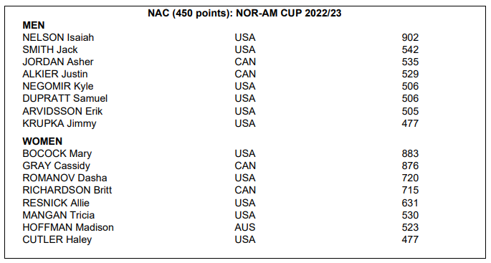





**Continental Cup event winners and winners according to the geographical affiliation may start 31 in that event in each Continental Cup 2023/24 (art. 3.2.2.2)**

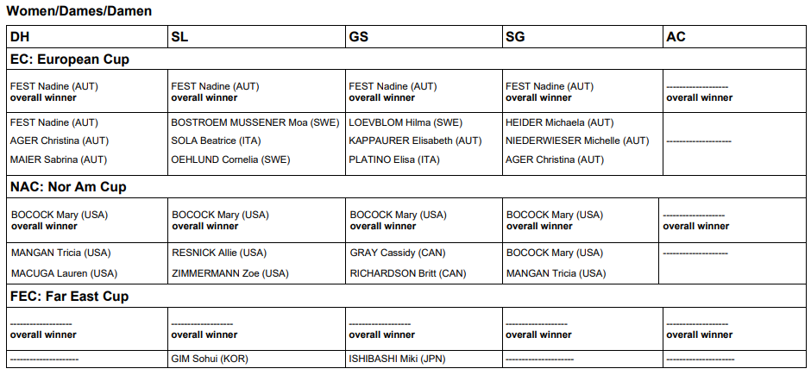

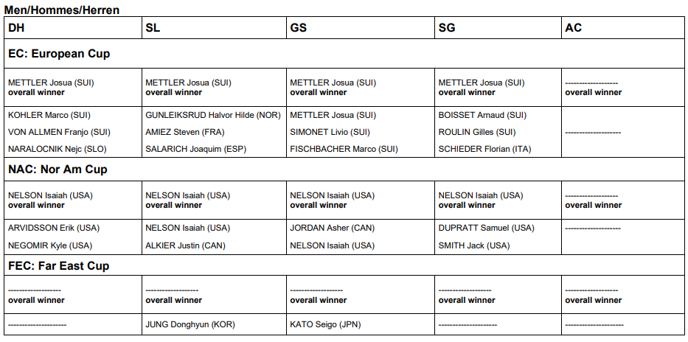

**NOTE: No Far East Cup (FEC) or South American Cup (SAC) winners noted.**

