HEAD TAX PROCEDURES & RESULT PACKET SUBMITTAL as of September 2020
The following procedures for payment of National Head Tax are basically for the Organizing Committees (OC) that do not use U.S. Ski & Snowboard’s online event registration system. If an OC uses the online event registration system, National Head Tax as well as required Region/Division Head Tax, will be deducted in accordance with Regional/Divisional requests prior to disbursement of entry fees to the OC. Required Head Tax not deducted remains the responsibility of the OC. The Head Tax Invoice (preferred) is available on the U.S. Ski & Snowboard website (refer to Pay Head Tax - page 6). It can be printed and it – or the Head Tax Accounting Sheet – and payment (either check or credit card information) can be submitted to U.S. Ski & Snowboard; if Head Tax is paid online, it can be paid with a credit card.
- Eastern Region:
- If the OC is able to scan/PDF/submit electronic Event Document Packets to resultpackets@usskiandsnowboard.org, they should include Janet Larson janet.larson@usskiandsnowboard.org as a recipient so she can verify accuracy/content.
- If the OC is unable to scan/PDF/submit electronic Event Document Packets, they must forward paper copy result packets via USPS directly to:
U.S. Ski & Snowboard/East
Attn: Janet Larson
P.O. Box 1720, Station A
Rutland, VT 05701
The accuracy/content of the paper copy packet will be verified and the packet will be forwarded to the U.S. Ski & Snowboard National Office.
- If U.S. Ski & Snowboard’s online Event Registration system was not used, either the Head Tax Invoice or the Head Tax Accounting Sheet, together with a List of Waived Athletes and Head Tax payments must be forwarded to the Eastern Office at the above address. After verification of accuracy, the Eastern Office will forward all Head Tax documents and payments (check or credit card information) to the U.S. Ski & Snowboard National Office.
- If the OC did use U.S. Ski & Snowboard’s online Event Registration system, the OC needs to log into the Event Administration system and confirm the accuracy of the accounting. Once the reconciliation is accepted online, the balance will be forwarded to the OC. If there are questions, contact U.S. Ski & Snowboard at compservices@usskiandsnowboard.org.
- Rocky/Central Region:
- Rocky Mountain Division race organizers all use U.S. Ski & Snowboard’s Athlete Event Registration system for all U.S. Ski & Snowboard Races and Non Scored Races.
- When U.S. Ski & Snowboard’s Registration system is used, all Rocky Mountain Division and National Head Tax amounts are collected by U.S. Ski & Snowboard Competition Services. Once the reconciliation is accepted online, the balance will be forwarded to the OC. If there are questions, contact U.S. Ski & Snowboard at compservices@usskiandsnowboard.org
- If the U.S. Ski & Snowboard Athlete Event Registration system is not used, or additional amounts are due, remaining Head Tax can be paid online with a credit card. If payment by check is required, Head Tax Invoice and payments can be sent to:
U.S. Ski & Snowboard
Competition Services
P.O. Box 100
Park City, UT 84060
- Central Division race organizers: If U.S. Ski & Snowboard’s online Event Registration system was not used, either the Head Tax Invoice or the Head Tax Accounting Sheet, together with a List of Waived Athletes and Head Tax payments must be forwarded to following:
Tom Barnes
U.S. Ski & Snowboard Central Division President
7593 Debbie Lane
Eden Prairie, MN 55346
- If the OC did use U.S. Ski & Snowboard’s online Event Registration system, the OC needs to log into the Event Administration system and confirm the accuracy of the accounting. Once the reconciliation is accepted online, the balance will be forwarded to the OC. If there are questions, contact U.S. Ski & Snowboard at compservices@usskiandsnowboard.org. The list of waived athletes must be sent to Tom Barnes at the above address.
3. Western Region:
- Race Organizers will forward required Event Document Packets electronically to resultpackets@usskiandsnowboard.org. If not paid online with a credit card, Regional and National head tax checks go directly to the U.S. Ski & Snowboard National Office.
U.S. Ski & Snowboard
Attn: JJ Ehlers
PO Box 100
Park City, UT 84060
- Please also forward race results electronically to the respective divisional manager.
- If U.S. Ski & Snowboard Online Registration is used, or credit card payment is made, National, Regional, & Divisional Head Tax will be collected and dispersed to the appropriate entities by U.S. Ski & Snowboard.
- If U.S. Ski & Snowboard Online Registration is not used, there are two ways to reconcile head tax and submit the correct amount:
- Log into my U.S. Ski & Snowboard---using your Club Login. Choose event administration, accept the head tax numbers and pay online with a credit card.
- Print out Head Tax Accounting Sheet plus the list of waived athletes and mail the form, along with the Regional and National Head Tax check to the U.S. Ski & Snowboard office-address above.
- If you choose option 2, you will need to print out the Head Tax Accounting Sheet and mail the Divisional Head Tax check to:
- Alaska: Natalie Osborne, U.S. Ski & Snowboard AK Division, PO Box 160070, Big Sky, MT 59716
- Far West Skiing: Lucy Conklin, P.O. Box 2664, Truckee, Ca 96160
- Intermountain: Carma Burnett, P.O. Box 2354, Eagle, Idaho, 83616
- Northern: Sheri Hale, P.O. Box 217, Whitefish, MT 59937
- PNSA: Claudia Yamamoto, 1329 Section Ave., Quincy, WA 98848
MISCELLANEOUS:
- ALL Head Tax will be tracked and accounted for at the National, Regional and Divisional level.
- It is the responsibility of the OC to calculate Head Tax (refer to #48. Head Tax Accounting Sheet in the Master Packet of Forms on the U.S. Ski & Snowboard website) and verify that their calculations agree with those of U.S. Ski & Snowboard. If the calculations do not agree, contact U.S. Ski & Snowboard at compservices@usskiandsnowboard.org and reconcile differences. DO NOT submit payment to U.S. Ski & Snowboard until an agreement is reached.
- Head Tax for non-FIS collegiate divisional events is $250 per race/per gender.
- If you must file a payment request, and the payment is not yet available, please attach a copy of the payment request to the required accounting document and submit as required.
- Named U.S. Ski Team (A, B, C, D), U.S. Paralympic National Alpine Skiing Team (A, B, C, D) and named members of foreign teams recognized by FIS who are ranked in the top 350 in the world in one of the events being contested are eligible for Head Tax waivers.
- Foreign athletes enrolled in US universities/colleges/schools or who are members of or training with US clubs but who are ranked 100 or better (in the world) in one of the events being contested may not be required to pay event fees; these athletes are eligible for Head Tax waivers.
- In addition, at pre-determined events (e.g. U.S. Alpine National Championships), or at the discretion of the OC for other events, athletes ranked 100 or better (in the world) in one of the events being contested - regardless of their national team affiliation or national status - may not be required to pay event fees; the athletes are eligible for Head Tax waivers.
- Head tax must be paid for all other athletes.
- ALL Waivers are the responsibility of the corresponding Region/Division. If competitors other than named team members as previously noted, are granted Head Tax waivers, please follow applicable Regional/Divisional policies for payment/reimbursement.
- If race result document packets are not submitted electronically, include them with required Head Tax documents and payments, and forward via USPS to U.S. Ski & Snowboard’s National Office, ATTN: Competition Services.

NATIONAL HEAD TAX CALCULATION - ALPINE

Starts - DNS's - Waivers x Applicable $ Amount

Number of Competitors
on the START LIST 149

- # of 1st- Run Did Not Starts - 3
146

- Approved Waivers - 4

= 142

x Applicable $ Amount x $ --------

= Head Tax for THIS race. $______

*REGIONAL/DIVISIONAL HEAD TAX REQUIREMENTS AND AMOUNTS DIFFER – VERIFY IN CURRENT COMP GUIDE.

Head Tax Reconciliation

Head Tax Reconciliation

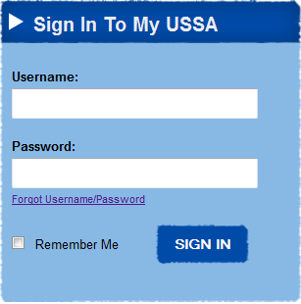
After your event results have been processed you can verify the Head Tax accounting online, accept the calculation (number of athletes included in Head Tax and amounts due), print and submit the U.S. Ski & Snowboard Head Tax Invoice and OC check or Pay Online with a Credit Card.

To use this process, please use the following Instructions:

Log In:
Log in using your Club
Login*

Enter your club's U.S. Ski & Snowboard.

Once you have logged in, you will need to choose Event
Administration from your dashboard..

Note: If you are already logged in with your personal
credentials, Club Login will not work. You will need to log out
from your personal credentials and then login with your Club
information. You may need to log out and close your browser.

*You should have received your login information via email. If you did not receive this email, or don't know your username or password, contact J.J. Ehlers at jj.ehlers@usskiandsnowboard.org

The Home Page
Once logged in, your home page will appear:
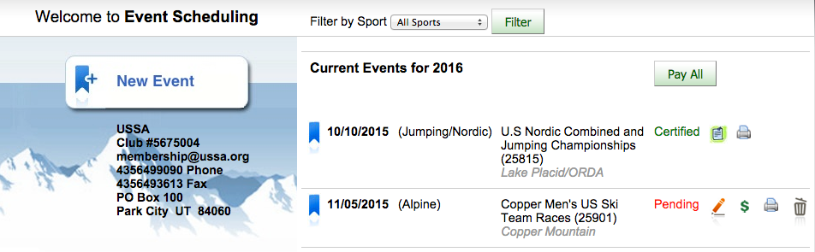

Select the page icon next to the completed event. This will direct you to the Alpine Scheduling Agreement:

Financial Summary of Event will provide the total amount of head tax that is owed for all races covered by the Schedule Agreement. (You can scroll down to view the Head Tax due for each race.). The number of starters is the number of starters recorded from the XML results submitted minus any U.S. Ski and Snowboard team members. If you have other athletes that should be exempt from head tax you must contact Competition Services to have the number changed. Compare the amount here with what is figured using the Head Tax Accounting sheet to make sure the numbers match. If there is a difference, contact Competition Services. If you agree with the amounts, then click . Do not accept or pay head tax until the amounts match. Once Head Tax is accepted you can to pay with a Credit Card or to send in with your check.

If you have questions about the amount, please contact Competition Services at 435.647.2037 or compservices@usskiandsnowboard.org.
Paying Head Tax

To pay Head Tax you can print a U.S. Ski & Snowboard Head Tax Invoice and submit it with a check to the following address:

U.S. Ski & Snowboard
Attention: Competition Services
P.O. Box 100
Park City, UT 84060

If payment by Credit Card is preferred, select Pay Head Tax. You will be directed to a screen similar to this one to complete payment. The “Balance Due U.S. Ski & Snowboard” will be charged to the designated credit card.

